The Castles on the Danube – Our Linking Heritage

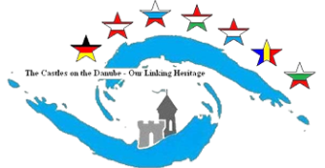****

**The fortification and weapons of medieval Bratislava**

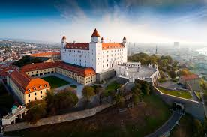 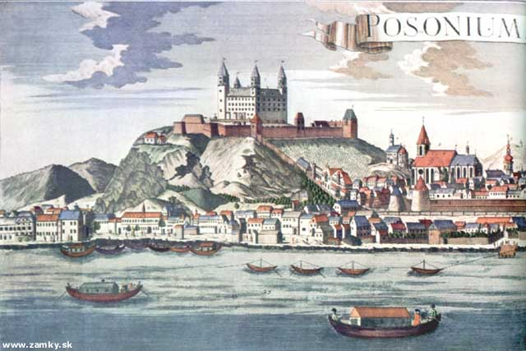

**The city walls and the castle fortifications, gates and bastions**

**The fortification and weapons of medieval Bratislava**

The discovery of **gun powder** had an impact on medieval warfare, when besides other types of weapons used in the 14th century, **shot-firers** quickly spread all over Europe. The first craftsmen to make them were blacksmiths, locksmiths and bell founders.

In Bratislava, in the first half of the 15th century besides many other kinds of crafts there existed also an important **gunsmith craft.**

Bratislava**municipal archive** contains a unique **accounting book** coming from the period of **free royal town** (Prešpork). It confirms that at that time the town not only paid for the gunsmiths services but also for building the fortification.

There is an important **record** coming from 1443. It presents a **list of all weapons located on medieval fortification**. This record is the oldest written record of such a character in the whole Hungary. The complete inventory was recorded by a three-member committee: Jorge Scholl – the gunsmith master, Jorge Zipper - the town notary, and a prominent burgher, Tomas Livener. On 2 August 1443 after the inspection of the town fortifications, towers and bastions, they recorded the sum

of 40 denarius for the drinks and food they had during that day. And somehow accidentally they left a list of all weapons in the book.

**The inventory contains a list of**:

125 pieces of cannons, a big amount of gunpowder, 870 arrows, 3 blasting arrows, 13 copper cannon balls, 52 leaden cannon balls, 22 pounds of leaden bullets, 62 pieces of rifles and 45 cannons of different types.

Vydrická gate was the best equipped entrance to the town having 8 cannons and 27 rifles. Vodná tower had 2 cannons and 12 rifles and there were 12 short-firer guns in Ungerfeind bastion. Michalská Gate had 5 rifles and 3 cannons. The town owned even more guns. They were all stored in the town gun–room.



**Vydrická gate**

**Michalská gate**

**The museum of weaponry and fortification**

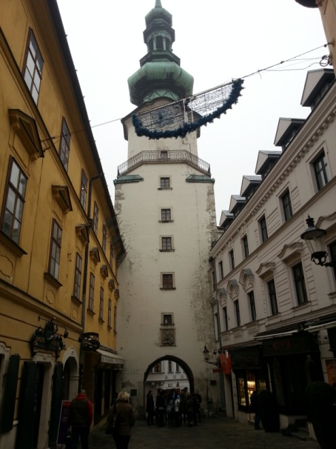 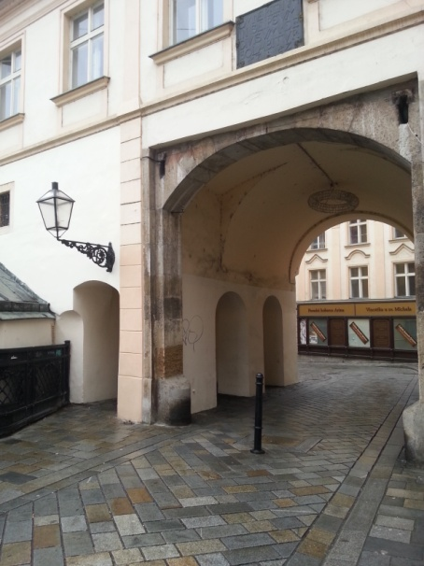

The museum is located in the original part of the medieval fortification. The town’s fortification started in the 13th century. At the end of the 14th century the town had 3 gates (Michalská, Vydrická, Laurinská); later the fourth one called Rybárska was built.

In the period of the 15 the century the outer town’s fortification had these gates: Kozia, Shondorfská, Špitálska and Dunajská. The inner fortification’s bastions (Masiarska, Obuvnícka, Pekárska and Prašná) contained a lot of military equipment.

In the 18th century the fortifications lost their importance, they were rebuilt and of all medieval gates only **Michael’s gate** remained. Its tower was renovated in a brogue style. The statue of archangel Gabriel made of copper was placed on its top and a gothic bridge nearby was replaced with a baroque one decorated with several statues of the saints.

**The museum presents** the history of the town’s fortification and there is an exhibition of all kinds of weaponry too. It also presents the crafts which at the time made most of the town’s rifles and cannons. There are records from the early 15th century mentioning the existence of masters making the weaponry. After the 18th when the weaponry craft reached its peak, the craftsmen made special weaponry for hunters. The exhibits on display are targets of different kinds of design which were used by the members of the shooters associated in their own alliance.

A part of exhibition presents the era of the existence of international legions (1914-1918) operating in France, Italy, America and Russia.

The top floor of the tower provides perfect views of the historic part of Bratislava and its surroundings.

Michalská gate is the only remaining of 4 gates.

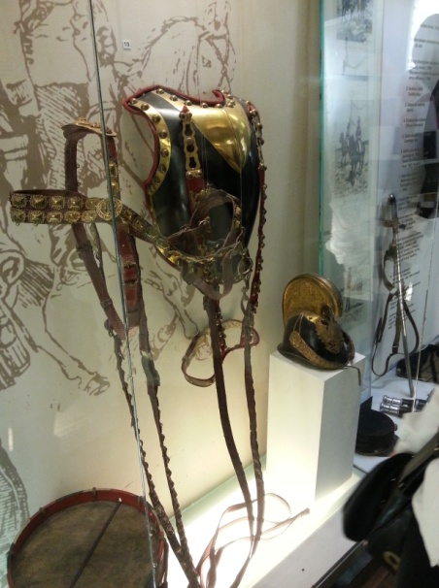 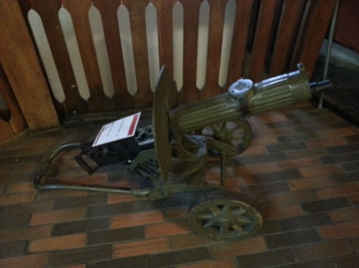

**The museum**

**exhibits**

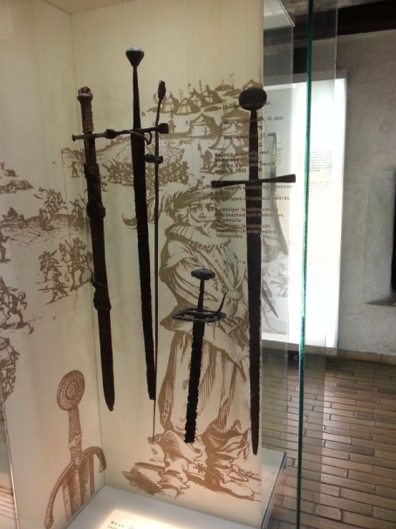 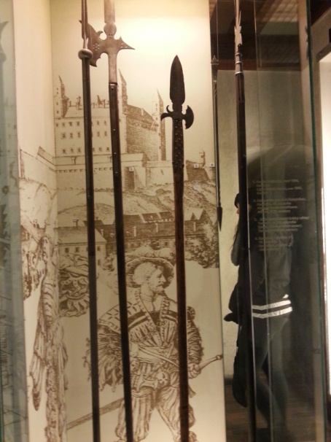

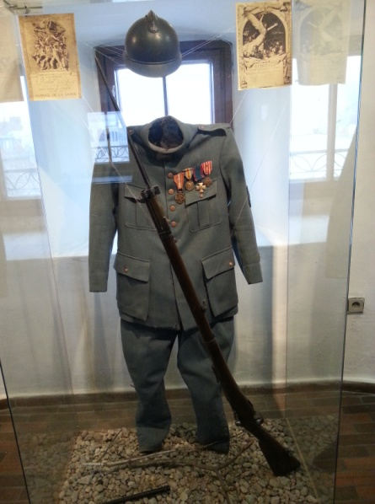 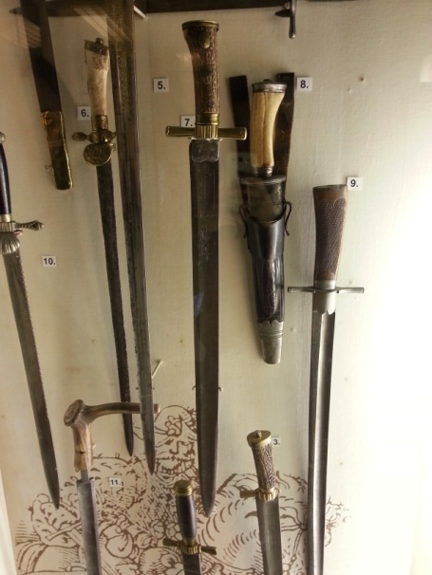

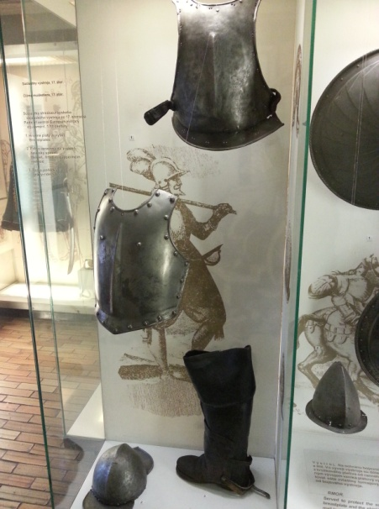 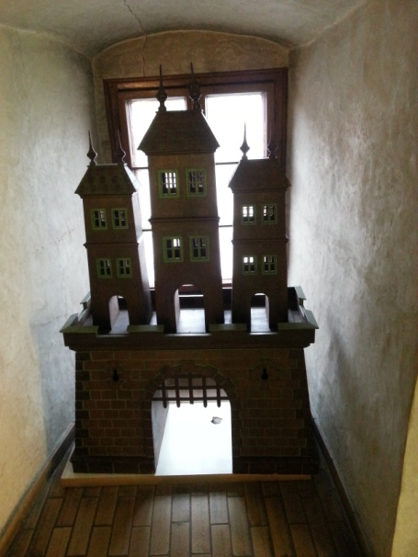

**Karl Hugo Frech, the artist**

**K.H.Frech** was born on 9th September 1883 inStuttgart-Gaisburg, Germany. He was fascinated by painting and drawing and went to study lithography at G.F. Schreiber Art Institute in Esslingen. Between 1903 and 1905 he attended the Academy of Applied Arts in Stuttgart, where he later worked as an illustrator and graphic artist. He also studied at the Academy of Fine Arts in Karlsruhe. He travelled around Europe and when he married in 1914 he moved to Bratislava, where he spent most of his life. He made his living as a painter and a graphic artist and also contributed with **illustrations** to Bratislava newspapers Pressburger Zeitung and participated in illustrating various books or albums of prints with the subject of Bratislava. Karl Frech died on 27 July 1945 near Austrian town Steyr.

His **tempera and oil paintings**, **prints** as well as **sketches and drawingsrepresent an accurate topographic record of the city atmosphere.** With the precise depiction and picturesque, the familiar and unknown places give us an image of the former romantic nature and the history Bratislava. The selection K.H.Frech is presented in **Bratislava Art Gallery**.

**K.H. Frech´s pieces of work**

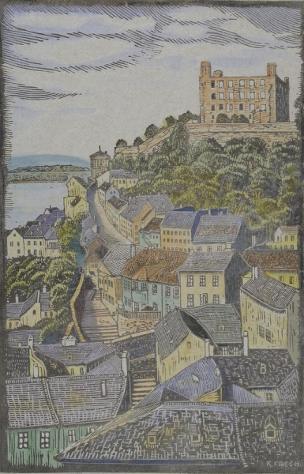

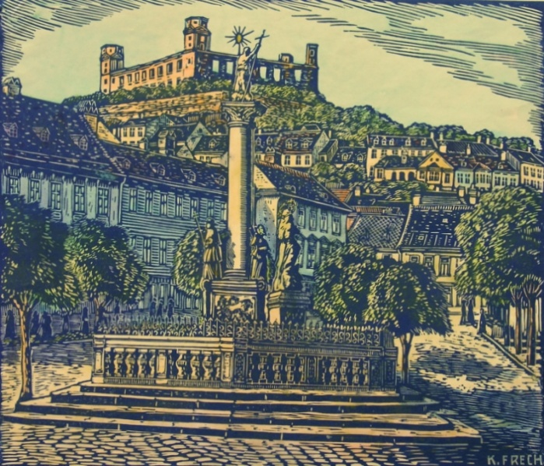 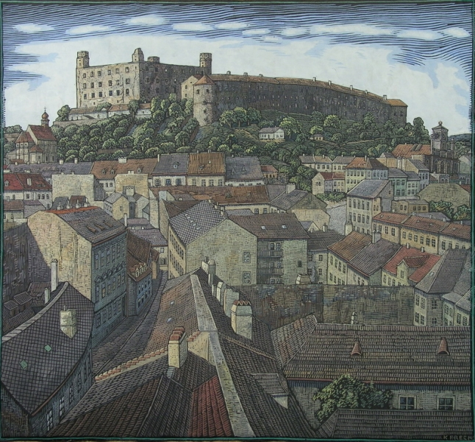

**The remains of the city walls**

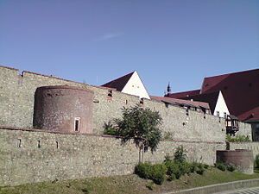

**City walls** are closed to public due their bad condition. There are plans to renovate and open them to the residents and tourist of Bratislava. During Christmas a safe part of the fortifications invited hundreds of people who could visit medieval Christmas market, try special foods and drinks, watch craftsmen working and buy their products. There was also a presentation of historic weaponry, visitors could listen to a period music and see people dressed in period costumes.

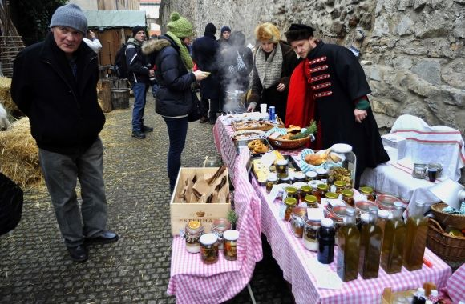

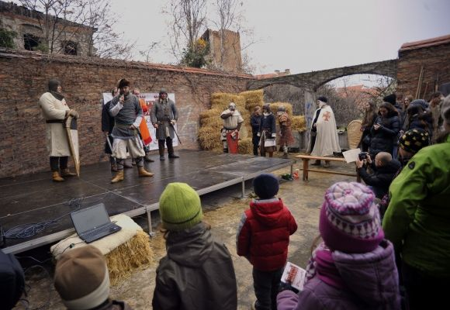

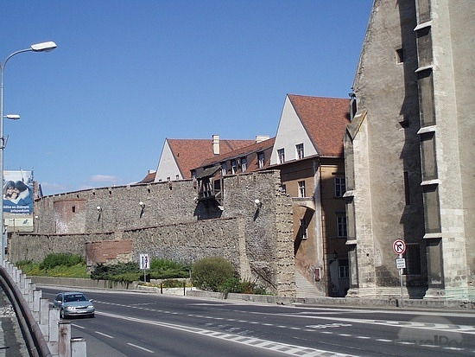

**Bratislava castle fortifications, their gates and bastions**

The fact that in 1241 the Tatars were not able to conquer the castle suggests that it must have had a really **functional fortification.** Since the castle was constantly threatened, **King Sigmund** ordered not only to rebuild the castle but also to fortify the castle and the town. There is a record from 1297 about the payment for these works. Both **inner and outer fortifications** were built according to the newest defense, military and building knowledge.

During the 17th century the outer fortification underwent a massive renovation. The walls of it became taller and a few new bastions for locating cannons were erected.

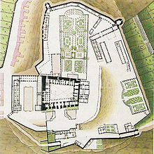 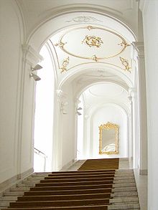

In the 18 century during the reign of **Maria Theresa** the focus of renovations was on the castle itself. (See the plan above)

**The castle gates:**

**Žigmundova brána** (15th c.)

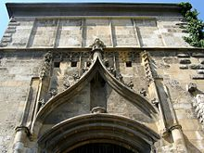

**Viedenská brána** (1712)

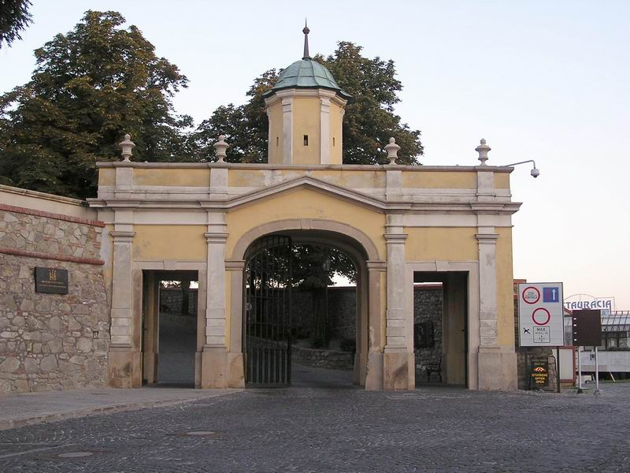

**Leopoldova brána** (1674)

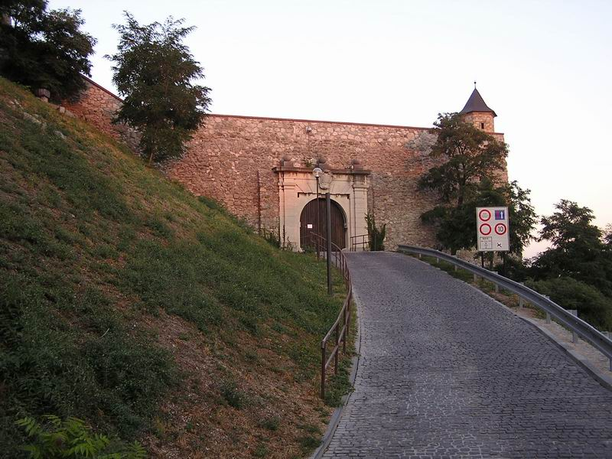

**Mikulášska brána**

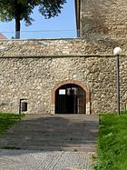

**Víťazná brána**

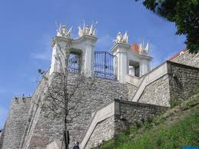

**Bastion Luginsland**

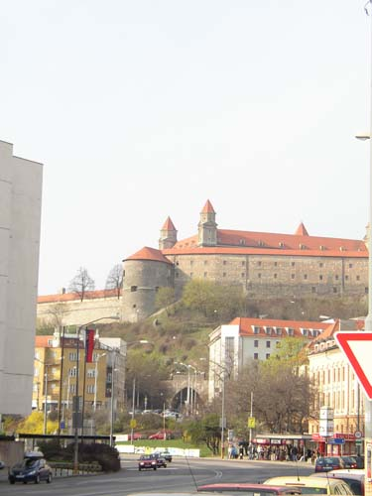

In 1802 the castle was assigned to the military as barracks. This was the beginning of the end of the castle. The rococo interiors of the castle were adapted in order to house some 1500 soldiers.

In 1809 the castle was bombarded by cannons by Napoleon´s troops. On 28 May 1811, the castle caught fire due to carelessness of the soldiers. The fire even spread into parts of the town.

The castle was in ruins from 1811 – 1953.

Long restoration works began in 1957 after archaeological and architectural research. The restoration was done to the last Baroque state of the main building, but at many places older Gothic and Renaissance preserved were restored as well.

The last massive reconstruction started in 2008.

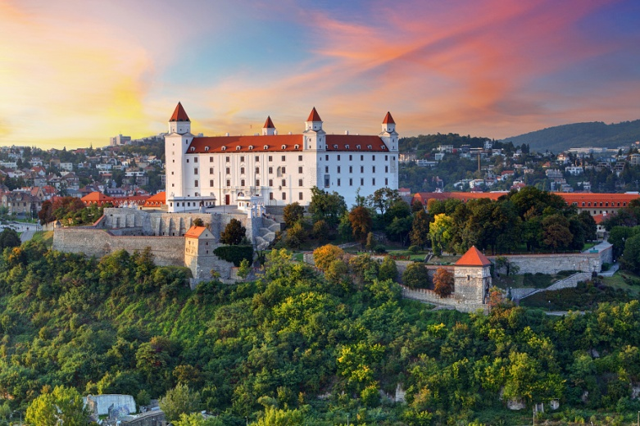

**The plan** for the further renovation of the castle area contains the following: baroque gardens, orangery, riding-hall and new garages.

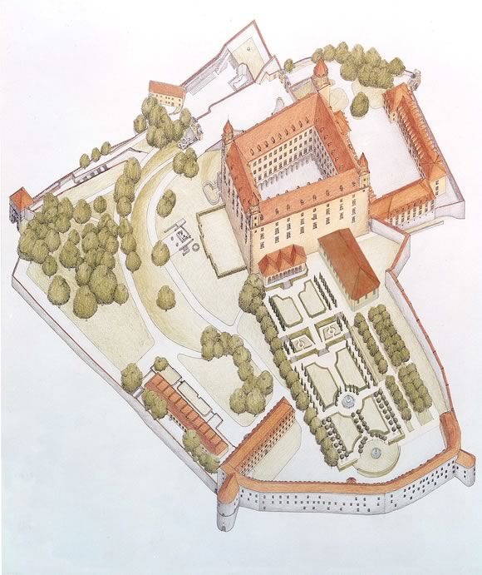

**The model of the castle hill**

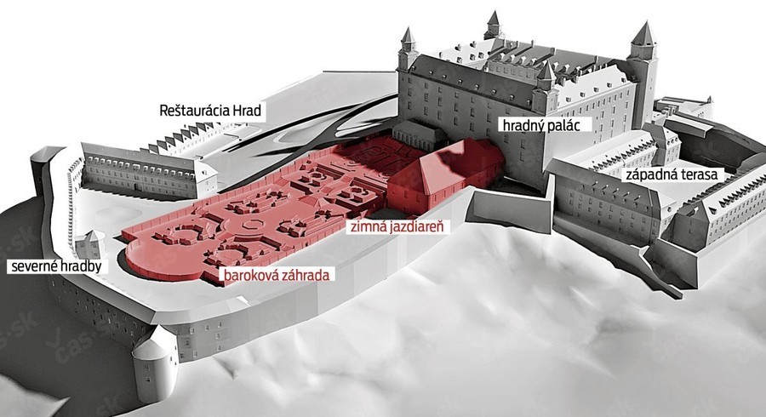

**The resources**

<https://www.google.sk/#q=Karl+Hugo+Frech>

<http://en.wikipedia.org/wiki/Bratislava_Fortifications>

https://www.google.sk/#q=bratislava+city+walls

<http://sk.wikipedia.org/wiki/sk:Bratislavsk%C3%BD%20hrad?uselang=en>

<http://sk.wikipedia.org/wiki/sk:Bratislavsk%C3%BD%20hrad?uselang=en>

<http://en.wikipedia.org/wiki/Bratislava_Castle>

<https://www.google.sk/#q=Bratislavsk%C3%BD%20hrad>

Bratislavské noviny

Program celoživotného vzdelávania poskytuje podporu projektu:

„The Castles on the Danube – Our Linking Heritage. “

Za obsah produktov zodpovedajú výlučne študenti Gymnázia Ivana Horvátha (2.C).

Európska komisia a ani Národná agentúra nenesú zodpovednosť za použitie týchto informácií.

