Bratislava legends, fables and historic pictures
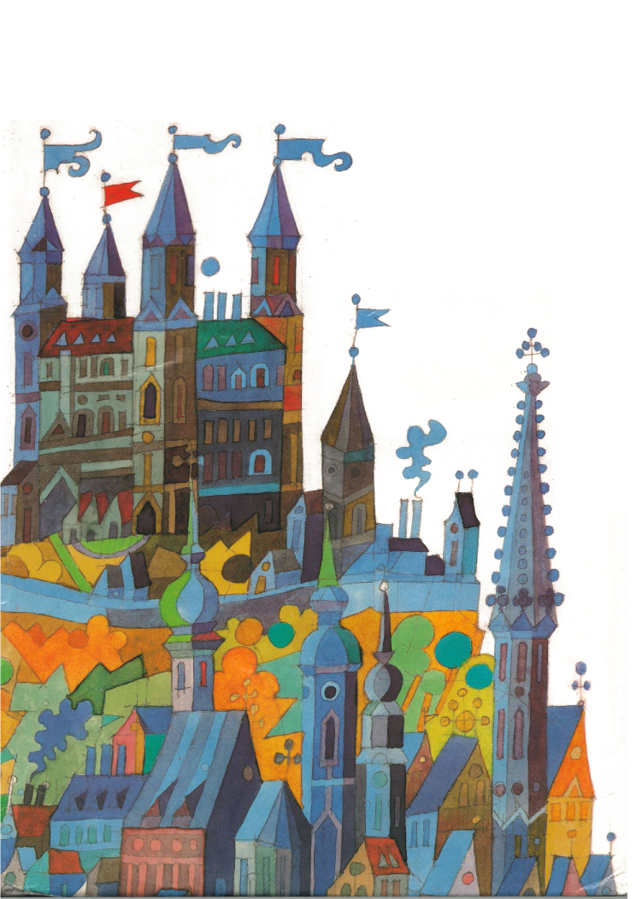
Mária Ďuríčková

This book was published to 700th anniversary of granting Bratislava the status o a city.
Contents

1. The Fish King 3
2. The „Learned“ Wine 9
3. The Danube Queen 14
4. The legend about the castle weel 22

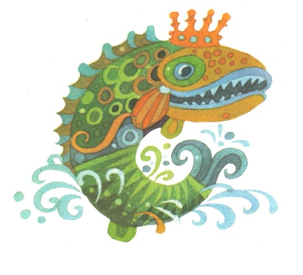
The Fish King

The Danube was rushing and streaming, coming in waves, waving, roaring and with its white foam it was rinsing the banks. The river had spread over the fertile plain and divided it into seventy seven islands with its arms. The Danube made plains soaked and marshlands covered by reeds and galingales. It was doing what it wanted to, no human could face it.
In those days various water powers lived in the Danube depths. The river obeyed them, each its wave was subordinated to them. Danube waters sometimes helped people, but often they caused even deaths.
*
Once upon the beginning of the winter, a very-very long time ago, an old fisherman was trying to catch fish the quiet Danube cove. While he was sloshing in the cold water a huge fish emerged right in front of him. He had never seen such a fish in his life. Its scales were green, overgrown with moss, and it was shimmering like silver and gemstones.
“I wish you good luck in catching the fish, old man." said the fish with a human voice. “I´d like to send a message to all Danube fishermen. Would you help me with this? “
“I´d love to help you, if it´s a good thing, “ replied the fisherman.
„It is a good thing and it´s also very important,“ said the fish.
„Well, tell the fishermen that they can catch fish from the Danube in whichever day or night hour, on whichever day in the year, except for Christmas Eve. You know, on that day the Danube turns over onto its other side and it is forbidden to go fishing on this occasion. Tell the fishermen that the Fish King leaves this message for them.“
Then the Fish King disappeared in the depth.
The old fisherman handed in the message to the fishermen right on that day. But they started laughing. “Hmm, the old man took a nap and was dreaming about the Fish King!” they thought to themselves. Mainly young fishermen from the lower flow were laughing, and making fun of the old man. On Christmas Eve, on purpose, they went to the river and they never came back. After a while here and there their dead bodies came out from the river.
Now fishermen believed the order of the Fish King and truly obeyed it. Not just for a year or two, but for the whole centuries.
And what happened the other day?
A short time before Christmas, Queen Maria Theresa with her royal court, came suddenly and unexpectedly to Bratislava, and wanted to spend Christmas holidays there. Soon after, Bratislava fishermen received an order from her to catch some fish for the Christmas Eve royal table.
The fishermen were astonished, mainly those older and more experienced ones. After a short hesitation a young fisherman called Jankto being pretty courageous asked for an admission to see the monarch in the castle. He told Maria Theresa about the Fish King´s strict prohibition of catching fish during Christmas Eve.
“The Fish King?“ the Queen laughed and then said, “but he is just the king of fish, but I’m the Queen and empress of the whole empire, therefore also of the Danube! “ She started laughing again. “Just go fishing, do not worry. After all, you would not let the royal table be without any fish on Christmas Eve, would you!“
Thoughtful Jankto came back to his friends. When he announced them the queen´s answer, young fishermen merrily started the fishing preparations. For a long time, they all considered the Fish King´s prohibition a fairytale. And now the Queen agreed with them.
Since it´s always getting dark early in winter, the fishermen set up the fire on the river bank to attract the fish. Then they got into the boats and were paddling until they got to the unfrozen middle of the river. They threw out nets there and waited.
It was an outstanding angling! The water around the boats was full of fish, a head next to head, and a tail next to tail. It looked as if the boats had been floating on fish not on the water. The steam moved up from their breath as if the Danube was boiling. You would hardly sing three verses of the Christmas carol, and the boats were filled with fish, just take them to the bank!
And in that moment the water rapidly billowed and right in the middle an enormous fish appeared. Its scales were green, moss-covered, and glittering like silver and gems.
Despite the fish moved its tail fin just a little, the waves moved suddenly and were as high as houses. The boats overturned, enormous weight of fish pressed fishermen on the Danube’s bottom. Only one of them survived, fisherman Jankto. A huge wave threw him far away on the bank of the river Danube.
He stood up, looked on the river. It was quiet and calm again, as if nothing had happened.
Jankto sighed and went away to announce that sad news to the others. And as he was walking, he suddenly realized that something was moving in his shirt. He put his hand in it and pulled out a beautiful sturgeon. He thought, “Fish King must be sending it to Queen Maria Theresa, in order not to stay without Christmas fish!”
However, sturgeon didn’t taste good to Maria Theresa, although it is the most precious Danube fish. The Queen felt sad that she caused so much unhappiness. She understood how sad Christmas the families of the dead fishermen had. To avoid situations like this in the future, she prohibited fishing during the Christmas time.

The Learnt wine

There were rumors spreading over the country that the King would generously gift the man who would made such wine, from which nobody would get drunk, from which nobody would laugh with no reason and from which nobody would do anything wrong. He wanted thoughtful and dominant wine. It should have some specific qualities, for example it should awake happiness in heart and rationality in head. An elderly man called Radoš living in the area under Bratislava castle also heard this rumour.
He thought to himself, “ Isn´t it strange to ask for such wine? The required wine should literally have to be intelligent, even learnt!” How much he has worked in vineyards, how many barrels of wine he has produced, but he has never heard about wine like that. The longer he was thinking about it, the more it was sprawling in his head. “How come nobody has made such wine so far? Maybe because nobody taught it.”, he thought to himself. The old man decided to make a try. What if he talked to his wine, not only with hands but also with some wise words? When the wine is young, who knows, maybe it can remember what it is learnt.
He planted the vineyard with young wine and was telling it stories about his great grandfather, the first wine maker of all times. He continued talking to the grapes about the people working in the vineyard.
Radoš was working in the vineyard from the sunrise to sunset. He talked to the young wine about everyone he knew, his father and mother, grandpa and grandma, about everyone wise from his family line. He was protecting it, so that it would be neither bitter nor acidic, neither solid nor weak. He preferred not to rush, because rushed work is never durable.
As the wine was growing like from water and the grapes were getting heavier, Radoš told them all biblical parables and stories of seven wise men.
When the wine became rape, he started pressing it. The wooden press was squeezing the grapes and while the juice was coming out of it, Radoš was talking to it. "Make effort so that you won´t be just ordinary drink! May a sip of you makes hearts happy, remove the sadness and prevent heads from getting mad.”
A then something crossed his mind. A barrel! Should I put such wine into ordinary barrels? Definitely not!
Radoš came to a barrel-maker, a well-known master Tobiáš. He manifested him all the truth about the King´s wishes. Hearing it, master Tobiáš get down to work. What a barrel he made! What a barrel! The biggest barrel! He decorated it with a beautiful carving. It reflected the king´s chamber, where the king was sitting at the table, having a glass of wine in one hand and Bratislava heraldry in his second one. There were three towers in it with the city walls all around them. That was a barrel! It was big and beautiful. All Radoš's learnt wine fit into it perfectly.
And then, when the wine in the barrel got mature, old Radoš walked around it singing all sorts of good songs about wine. After all the wine matured, Radoš tasted it, and it seemed alright. He took one jug of it and went to see the king, who visited Bratislava and stayed according to his habits in a magnificent king´s mansion.
"I am bringing the king the wine he's wanted," he said to the guards at the gate which led him to the king's chamber.
The old man bowed to the monarch, greeted him sincerely and handed in the wine he brought. The monarch started talking to him, using the language of his fathers and grandfathers. He asked Radoš how he had taught the wine and Radoš told him everything from the beginning till the end. The King was burning from curiosity. He poured the wine and tried it.
"It is .....!", he screamed surprisingly and took a drink once again eagerly.
"This is it!" screamed the ruler happily and added, "I wanted wine just like this! I will buy all your wine from you. My servant will transport it to Buda."
Radoš sold his learnt wine in a carved barrel. The servant loaded the barrel onto the wagon and carried it to the port. There about a hundred of soldiers helped with embarking. But the barrel was too heavy to move, it slipped, fell on the coastal rocks and it broke into several pieces. All learnt wine spill into the Danube River. Since that time nobody had ever managed to produce wine like that. Right after this accident the Danube fish changed. Now you can hardly catch them into a net.
"They act as if they were learnt, “complained the fishermen.
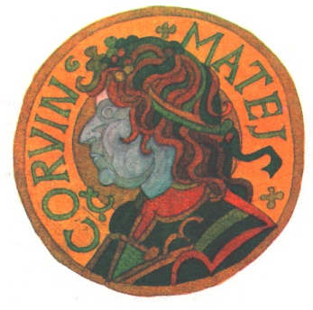
But the truth is that man who was most sorry for what had happened was of course the king. How intelligent he could have been, if he had drunk not only one sip of that wine but the whole barrel? It is said that this king was intelligent enough, anyway, he made only a few mistakes during his reign. But if the wine hadn´t poured out into the river, who knows, he might have made no mistakes in his life at all.
That king was named Mathews Corvine.

The Danube Queen

In one of the branches of the Danube River stood a charming water palace, hidden in the depth of marshes. The stairs were made of green gold; the walls were painted in white gold, balcony in red and roofs in golden blue. There lived the Nixies, slim and fragile; their faces looked like snowdrops and their eyes were like the summer sky. Their hair was their glory: long, lush, undone, with a green shade. People recognized them easily according to their hair and their skirts, steeped to knees. They walked with undone mane and wet skirt. People looked at them unfriendly and envied their beauty of impure origin.
Nixies walked among people rarely, merely when they needed to get a daily bread. They didn´t go alone, only in pairs. They never walked as far as the town centre and they always stopped at the suburb. Naturally, they were immediately recognized and served ungratefully, even though they paid in pure gold.
Only the butcher, Jug, treated them kindly and humanly.
“Good afternoon, lovely damsels, how can I help you?”, he asked and threw the most beautiful piece of meat in the bowl.
He was mainly paying attention to one of them, charming Rosava. He served, as it should be, and when they were paying, he was only looking at Rosava's face, her pleasing appearance. He suspected, where this beautiful long-haired girl came from and where she always returned, but nothing discouraged him. When she came near him, he couldn't take his eyes off her and when she left, he felt as if she stole a half of his heart away.
In the late afternoon, when Jug closed the pub and handed over the takings to the headmaster, his steps were irresistibly leading him towards the Danube River, wandering here and there.
Once upon the beginning of the summer, the night was remarkably beautiful, bright and warm. The stars were sparkling, and the moon was shining among them. The fresh breeze suddenly blew into the luminous silence. Jug shivered as he heard the magical sound. He started walking silently, paying attention not to disturb the sound. He spotted them at last, the Nixies. They were sitting on willows and alder-trees, swinging above the water; their hair was flying in the moonlight breeze with their skirts touching the water.
Jug came closer and just then he stepped on a twig, which split underneath his feet.
The Nixies screamed, jumped off the branches and started running along the shore. Jug was attacked by those magical creatures.
“You have hunted down our hide-out! “, screamed the Nymphs.
“We won´t ever forgive him for what he has done! We will make him dance to death! “
Rosava was trying to save him:
“My dear sisters, stop threatening him! Let the Danube Queen make a decision!”
The Fairies jibbed. The Queen had always warned them not to act recklessly.
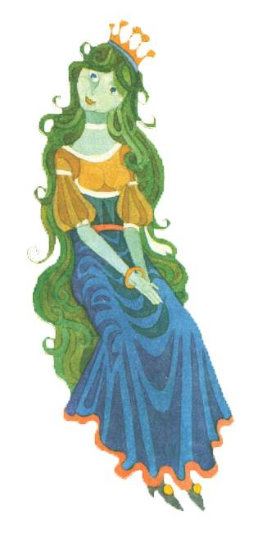
“Let it be,” they agreed, “we ´re going to introduce him to the queen.”
Rosava came closer to the water and whipped with a wand on the surface. The river was divided and the two parts stood against each other like massive walls. Between these walls a path, situated on the bottom of the river led to the castle itself. Jug was brought to the siege along it. On the siege sat the Danube Queen, draped in sparkling green hair, with a crown shining on her head.
“Danube Queen”, screamed the Fairies, “this youngster has hunted down our hide-out and disturbed us during our game of happiness. We ask your permission to make him dance to death according to our old fairy law. “
Then Rosava started to speak.
“Let me tell something, queen. “
“Speak!”
“I know this young man, his name is Jug. When we purchase some staple food, he treats us kindly and humanly and he always serves us well. Although he is a human, he has a heart of a swan; you just need to look into his eyes. And for this reason I plead you, Your Majesty, give him mercy. “
The queen gave a nod to him to stand up.
“I’m giving you mercy, Jug, youngster of the human clan,” said the Queen as softly as a stream of water.
“I thank you for your amiable behaviour to my sisters, when they come to your shop. Once there was a time when people had love and respect for us, they even held celebrations in our honour. They were protecting our hide-outs and were paying attention to walk around them not to disturb us in any way. Nowadays, everything has changed. Folks dislike us, we are afraid to walk by the shore. And today a human, you, Jug, discovered our last hide-away.”
“I won’t say a word about this in front of anyone, majestic Queen,” said Jug.
“The Nymphs don’t feel safe in their discovered hide-out any longer and are obliged to leave it.“ The Queen raised her iridescent head and looked at her companions: “We will move away to the Black Sea, sisters.”
“Rosava too?” blurted out Jug. “I came here to look for her, to ask you for her hand in marriage. Don’t be afraid, I will protect her from men, I won’t leave her and won’t let anything harmful happen to her.”
“You are courageous and honest, Jug,” said the Danube Queen.
“However, since the beginning of times I’ve known people’s characters and I guarantee you I know more about them than you do. The folks would loathe her and eventually get rid of her, but I will let her speak her own words.”
All eyes were set on Rosava.
“I agree with you, my Queen,” said Rosava in a calm voice. “I’ve learnt to read human eyes and look through them right to their hearts. People in general have a heart of a muskie, a shark and a snake. It´s cruel. Once I saw a woman lit on fire because of having red hair. So I’m sorry good Jug, I’m choosing not to go. I’m leaving with my sisters.”
The same cheerful laugh was heard, as if someone was pouring silver beads on a golden table.
The Danube Queen showed a smile on her face.
“You’ve made the right decision, Rosava. Show Jug a way out of the palace, so that he can enter his world in peace.”
Rosava was leading the youngster along the chambers. As they were passing the kitchen, she grabbed a broom, picked up the rubbish underneath it and tucked it in Jug’s pocket as she was waving him goodbye.
Jug set out for his home and was thinking about taking a last look at Rosava, but the doors were already shut. As he was approaching the river bank, he reached into his pocket and noticed there was some rubbish in it. “What had Rosava put there?”, he thought to himself.
Offended, he threw all the rubbish on the bottom of the Danube River. He turned around but the palace was gone.
Jug arrived home and when he was taking off his coat something made a strange noise in his pocket. What could it be? There were two pieces of gold, the remains of fairy´s rubbish. He was regretting the moment he had thrown most pieces into the river before. He was hoping to see Rosava at the butcher’s again, but his hopes were for nothing. She didn’t come, not even any of her sisters. They all moved away to the Black Sea.
The Nixies with sky-blue eyes were gone and the Danube waters lost their blue colour. Now it is either grey or brown. But whenever the sky above the river turns blue, the Danube reflects the shine of this colour as if it wanted to remind people the days when the beautiful sky-blue eyed fairies lived there.

The legend about the castle well

The town of Bratislava had never really got on well with Bratislava castle. It often happened that they stood against each other like enemies. For example when the castle district administrator supported one candidate of the Ugrian throne and the free royal city of Bratislava supported another one. There were times when the city and the castle shot at each other. The Tower of St. Martin’s Cathedral was the main bastion of the city against the castle.
So it only seems natural that the city and the castle kept secrets from one another.
The legend about the castle well tells us about one of these secrets.
People in the city said that it happened like this:
The castle administrator Štefan Rozgon made a decision to dig a well in the castle. He called the prisoners he kept in the castle dungeon and told them, “Men, listen to me carefully. If you dig a well in the castle, you will all receive freedom and you will be free to return to your home country. Do you all agree?“
The prisoners agreed and started their work immediately. They were digging the well for almost a year. When the water finally appeared, they believed, that the district administrator Rozgon would keep his promise, so when they finished the work they even gave him one golden necklace.
”Your Excellency, we made this necklace from the pieces of gold we found while digging the well and bore leaving from our captivity, we would like to present this necklace to the enlightened countess.“
Those poor guys had no idea that this act of gratitude would lead to their destruction.
The administrator was inspecting the necklace while his wise advisors whispered to him:
“Those men must have found a lot of gold and now they are only giving you this necklace. They should be punished!“
The administrator Rozgon asked the prisoners for the rest of the gold, but they asserted they had no more gold left. They were tortured but the prisoners kept telling that they didn’t have more gold. So the administrator Rozgon made a decision to push the prisoners from the ramparts to the pit.
His wife, the countess was so shocked with her husband´ s cruelty that she didn´t have peace even in her grave. After her death she returned as a white ghost and walked around the castle yard to buy out her husband´s sins.
This is how people in the city used to tell the story. But people in the castle knew that the story was completely different.

The castle administrator, count Štefan Rozgon was standing by the window watching the donkeys walking out from the castle gate one by one carrying the barrels with water on their hips. The servants were there to empty them out into a stone tank.
“A castle without a well isn’t a real castle”, thought Rozgon to himself. There is water in the tank only when the heavens bless us or when donkeys bring them from the Danube. But what if there is drought or the path leading to the river will be blocked by the enemy? Then the castle walls will become our grave. God save us!
The district administrator ordered a Master well digger to come.
A middle-aged short man with wide shoulders arrived.
“I am a well digger Jakab of Vydrica, Your Excellence,” he bowed, “and I´m here to your order.”
“Welcome master Jakab,” said Rozgon, “I heard that you have magical wands that will show you where exactly in the ground the water is. Is it true?”
“Yes, it’s true that sometimes I manage to find water, Your Excellence.” Well digger Jakab took out a wand that looked like a pitchfork. “This wand will bend to the ground on the spot where the water well is.”
“Alright, well digger. Let your wand show us where we should start digging the well. And do your job properly!”
“I’ll do my best, Your Excellence. But this castle is located really high on a rock hill, so it might happen that there won’t be any water.”
“No, no, that cannot happen!” said Rozgon with anger in his eyes.
Despite the well digger was looking for water eagerly, the wand in his hands didn´t move at all. But then suddenly, it unexpectedly moved a little, but only a very little. He marked this place with a stone, but didn´t say anyone about it.
“So, where shall we start digging?” asked the impatient district administrator.
“Your Excellence, I searched every single centimeter of the ground but there is no water at all”, Jakab said.
The District administrator´s glum face meant nothing good.
“Or maybe there,” added Jakab with a little soul.
“There? What do you mean, there?” asked the district administrator.
“Here, I marked this place with a stone,” answered Jakab.
“I think there could be water somewhere very deep, on the Danube surface. We would have to dig deep, which is almost impossible for a man to do.”
The district administrator just waved with his hand.
“Don´t worry master Jakab, you won’t be alone to do your job. I´ll give you some helpers.”
At that time there were a half of a dozen prisoners in the jail and Rozgon called for them immediately.
They came, hairy like bears with chains on their hands and legs.
“Listen up! Sure death is waiting for you, you know that, but now there is a chance for you to be released. If you dig a well for me, you will be free to return to your country. Do you agree?”
The Men looked from one to another and then they looked at the eldest one. Their hairy faces came to life.
The eldest prisoner answered, “We agree.”
That same day they started digging.
At first it went well. The ground was firm from the start, but then they hit the rock and the work got more though. Every day they got only a few centimeters deeper, but they didn’t lose hope. They knew that they had to get as deep as the Danube surface.
A year passed by. They overused thirteen iron buckets but they didn’t find any water. The well got wet only when some rain fell into it. The well was so deep that when the diggers looked up, the heads of those who were looking down looked like poppy-seeds.
But there wasn’t even a drop of the water.
The district administrator called for Jakab.
“You lied to me! Your wand showed the wrong place! The bottom of the well is deeper than Danube and there’s still no sign of water there!”
“I didn’t tell the lie, Your Excellence. I wouldn’t dare! When I was down in the hole with my wand yesterday, it bended right here. Give us, please, a little more time.”
“Alright, I’ll give you one more month, but not an hour more! That is your last chance.”
The men continued digging day and night, but there was still no water.
“We have only one week left,” said Jakab, “we have to come up with a plan to get to the water.”
But everything they tried went to waste. They couldn’t find a drop of water.
A month passed by to the last day.
Starving and tired to death they stood in front of Rozgon.
“Your time is off and you didn’t succeed in finding the water”, said Rozgon. “Something is waiting for you - death. You are enemy rats and you, Master Jakab will die as well because you fooled me.”
Well digger Jakab just bended down his head.
And the prisoners look at one another and then at the eldest one. He stepped out of the line and he took out a golden necklace out of his pocket.
“Your Excellence,” said the old man and added, “we weren’t able to dig a well full of water, but we could dug this gold for you. While we were digging the ground, we found gold and in our free time we made this necklace for the enlightened countess. We are giving it to you as a gift of your ground and our hands.”
The district administrator’s face went soft for a while.
“Water would have bought you out, but not gold,” he said, “if I released you now, our enemies would find out that Bratislava castle has no well, and doesn´t have its own water. They would learn about our biggest weakness. And that’s why you have to die.”
He waved his hand at the guards who handcuffed the prisoners and Master Jakab and they threw them all down the castle walls.

There was some water in the well of Bratislava castle, but only when it rained or when it was brought from the Danube and it was kept in a secret. People living in the town only heard that the water in the castle well was not very tasty, that it smelled badly and there was not enough of it. That was why it had to be brought up to the castle by the means of donkeys.
Only now, in our times while renovating Bratislava castle and cleaning out the old well, they revealed the truth – three meters deeper there was clean, tasty and healthy water.
So Master Jakab and his wand didn´t lie after all, they just didn´t have enough time to prove their prediction.
Program celoživotného vzdelávania poskytuje podporu projektu:
„The Castles on the Danube – Our Linking Heritage. “
Za obsah produktov zodpovedajú výlučne študenti Gymnázia Ivana Horvátha (3.B).
Európska komisia a ani Národná agentúra nenesú zodpovednosť za použitie týchto informácií.

