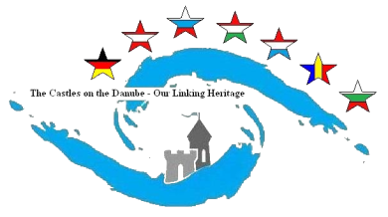
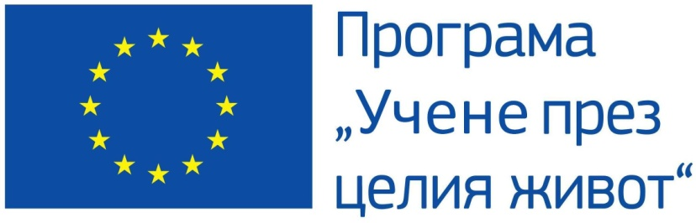

QUESTIONNAIRE № 1

- Does your school participate in the Comenius project?
а) Yes б) No

- What is the name of the project?
а) ..................................................................................... b) I don’t know

- Is there a place in the school where the information about the project is placed
а) Yes/What is the place?/ .......................... b) No c) I don’t know

- Do you know at least 2 activities carried out by the project?
а) Yes/ What are they?/___________________________
b) I don’t know

- What is the theme and purpose of the project?
…………………………………………………………………………………………...
...........................................................................................................................................

- What countries participate in the project?
...........................................................................................................................................

- What countries are not participating in the project? Why?
...........................................................................................................................................

- In which of them have you been?
..........................................................................................................................................

- What do you know about this country?
..........................................................................................................................................
...........................................................................................................................................

