The History of Bratislava Castle and Its Architectural Changes

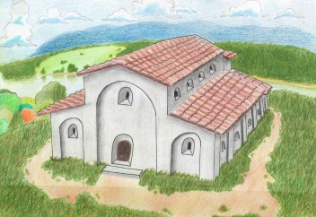
Bratislava castle hill was already populated in the late Palaeolithic period to the 1st century B.C. Some bricks and pieces of utility ceramics remained here after one of the Roman legions. In the 9th century a Slovanic hill-fort emerged on the castle hill. It had mainly a military function. The Slovanic people left the foundations of a three-aisle stone basilica here, which was one of the biggest in the Great Moravian Empire.

Drawing: (D. DRAGÚN, 3.C)

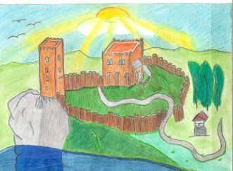
The first historical record of Bratislava castle dates from 907. At that time a battle between old Hungarian tribes and the Bavarians took place nearby. The Bratislava region gradually became a part of the Hungarian kingdom. In the first half of the 13th century, the castle was threatened by the Tatars, who destoyed the settlements and their surroundings. After this event, on the orders of Belo IV, wooden parts were replaced by a stone fortress. A residential tower with several floors and a prismatic defence tower (later known as a Crown tower) were built.

Drawing: (P. POSOVÁ, 3.C)

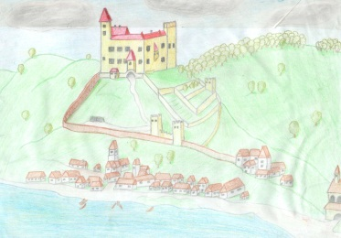
In the beginning of the 15th century the residential tower was dismantled. The castle had the form of a closed quadrangle, consisting of a two-storey castle palace and the crown tower. After the battle at Mohács a famous St. Stephen´s royal crown and other coronation jewellery were placed right there. Bratislava then became the capital and coronation town of Hungary for the next three centuries. Spectacular celebrations were held at the 16th c. Renaissance styled castle. Each coronation took place in St Martin´s cathedral.

Painting: (B. TAMÁŠOVÁ, 3.D)

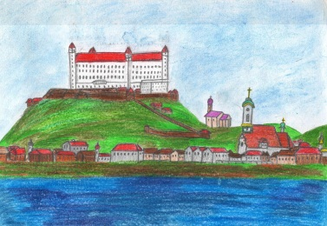
In 1683 the royal soldiers were sniping the Turks from the castle on their way to Vienna. They were heading towards it in two streams: going along the Danube and sailing on the Danube. In the 18th century, during the reign of Maria Theresa, the castle was rebuilt in a prestige baroque-rococo style. Johann Wolfgang Kempelen, a Bratislava inventor, constructed a water pipe, through which water from the Danube was transported directly to the castle. He also created the first weather station in Hungary and established it in the castle. Albert of Saxony-Teshen, Maria Theresa´s son-in-law kept a valuable collection of paintings by Durer, Rubens and Tiziano in the castle. Joseph II, Maria Theresa´s son established a school in the castle with the aim of educating Catholic priests there. Anton Bernolak, the first codifier of the literary Slovak language was one of this school´s graduates.

Painting: (B. TATIERSKA, 3.B)
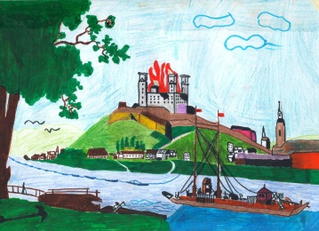
In the beginning of the 19th century the royal residence was converted into a garrison. May 28, 1811 was a disasterous day when the castle and the part of the town below it were destroyed by the fire.

Painting: (J. MIKULA, 3.C)

Reputedly, two soldiers manipulating the gunpowder carelessly, caused a huge explosion followed by the fire leaving the castle to fall into a ruin for the next 150 years.

In the period of Czechoslovakia, in 1956-1968 the castle underwent a large-scale renovation.
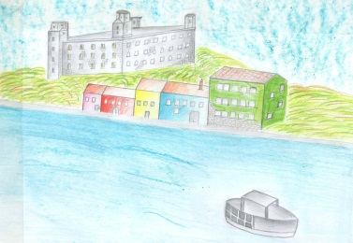

Drawing: (M. SLOBODOVÁ, 3.C)

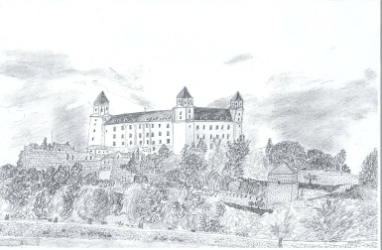
In 1961 Bratislava castle was declared a national cultural monument. Since 1967 it has been the seat of the Slovak National Museum. Nowadays the official rooms of the National Council of the Slovak Republic are there; there is also an exhibition of Slovak artists and in the former castle chapel there is a Music Hall. In 1992 the Constitution of the Slovak Republic was ratified there.

Drawing: (F. LUPTÁK, 2.C)

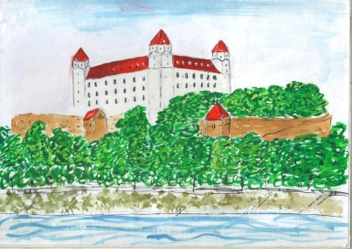
The last renovation of the castle in the era of the Independent Slovak Republic took place in 2008-2011. After it was completed, the castle was restored to its original appearance from the Theresian period.

Painting: (A. OLGYAYOVÁ, 3.B)

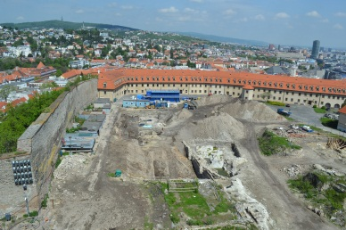
When the large historical and archaeological research finishes, at the site of the excavations (see the picture) there will be a Theresian baroque garden which Maria Theresa got built in the 18th c. The visitors to the castle will be provided with a car park built right below the garden.

Photo: (A. EŠTOK, the teacher)

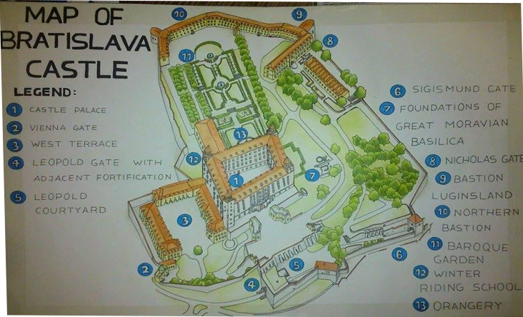
This all will be finished by 2016 according to the plan, when the Slovak Republic will hold the Presidency of the Council of European Union in Bratislava castle.

Drawing: (B.HOŠŠOVÁ, 3.C)

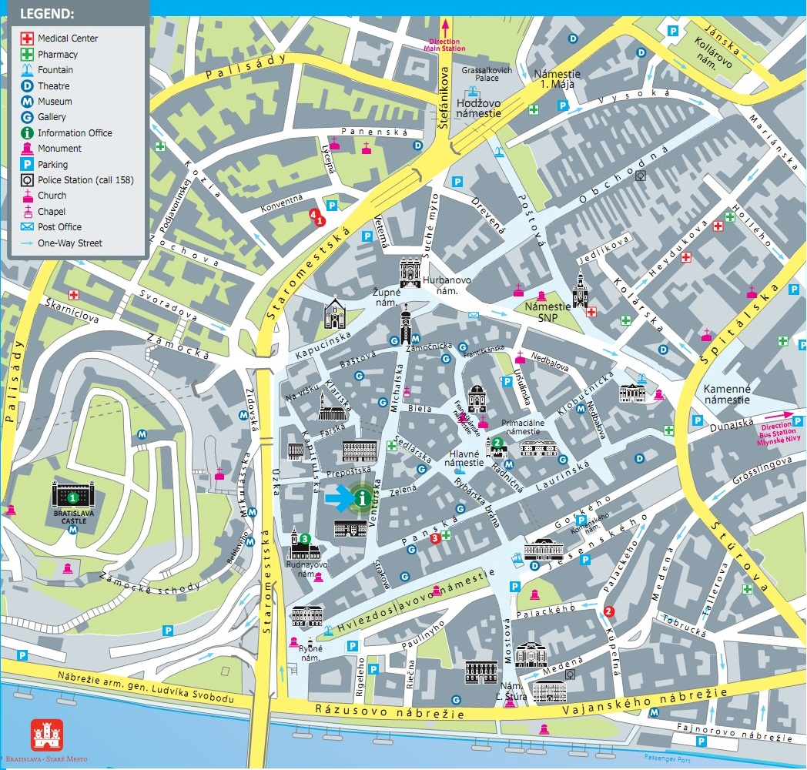
THE TOUR AROUND THE CASTLE

The access to Bratislava castle
The castle is situated on a castle hill (213m) and is accessible by passing one of three gates: Sisigmund gate (a short walk from the bottom of the SNP bridge), Vienna gate (from the Houses of the Parliament, trolleybus N°203, 207 from Hodžovo square - opposite the Presidential palace) and St Nicholas gate (taking paths from Bebleveho St. passing St Nicholas church).

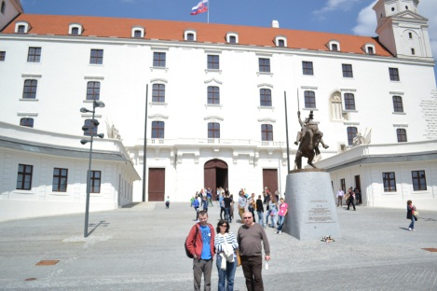
When you enter the area of the castle, enjoy the perfect views of the town from the Court of Honour before you enter the inner courtyard. The Court of Honour was originally built in the 18th c. Since the 15th c. till then there was a moat all around the castle and the entrance to the castle was through a drawbridge.

From here you can see the oldest preserved part of the castle from the thirteenth century. It is the only real tower – the other three are just turrets built up on the highest floor later in the 17th century.
A bronze statue of Svätopluk astride his horse can be seen in the centre of the Court of Honour . Svätopluk is remembered as the greatest king of the Great Moravian Empire.
The ticket office of Historical Museum, as a branch of the Slovak National Museum is on the right of the main entrance to the inner courtyard.
You will find the souvenir shop by walking towards the Vienna gate.
A large part of the castle area is the park where the foundations of the Great Moravian basilica are displayed. There is also a modest the statue of St. Elisabeth, who was born at Bratislava castle in 1207.

The castle restaurant “HRAD” situated nearby used to be a baroque stable, in which rare varieties of horses were kept.
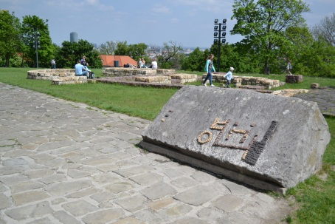
The northern border of the castle area is formed by a long baroque building from the 18th century, which today houses the Slovak National Council offices and the castle administration.

The inner courtyard is the starting point of the tour round the castle. After getting to the inner courtyard you may start the visit to the castle either by:
- entering the Palace - the Historic museum and keep going straight ahead;
- turning left to enter the Treasure Room (taking pictures is forbidden);
- turning right to get to the Knights´ Hall.

The inner courtyard and the well
In the 15th century, during the period of the reign of Sisigmund of Luxemburg the castle underwent a huge renovation and received its baroque appearance. He ordered a well to be dug, which is 85 metres deep and can be seen in the corner of the courtyard.
During the Cultural Summer Festival this yard provides cultural events for the visitors who love theatrical performances, Shakespeare´s plays in particular.

THE GROUND FLOOR
It provides a cloakroom and also a lift to the upper floors.

The Palace
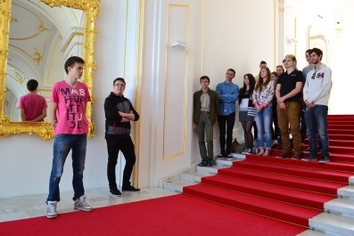
Behind the entrance on the ground floor take the arcade corridor that leads to the exhibitions of the Slovak National Museum on the second floor. The beautiful wide marble baroque ceremonial staircase was built during the baroque reconstruction. This part of the Castle was completely destroyed during the fire. It is now renewed to its former beauty – the golden parts were gilded using golden leaves. The steps of the stairs are not of the usual height. Most likely it was just a result of the fashion allowing women to walk up the stairs in the big skirts. However, there is an urban legend that the steps were built short to make it easy for Queen Maria Theresa to get upstairs on horseback. What makes this staircase unique is not only its height, but also its width.
When Maria Theresa of Austria became queen of the Kingdom of Hungary in 1740, she decided to have her residences both in Vienna and in Pressburg Castle in Bratislava. A corresponding conversion of the defence castle into a modern royal residence was performed in the second half of the 18th century. The interior of the castle carried the features of rococo and baroque styles. Austrian architects designed the new appearance of the staircases, watch towers, the courtyard; they built the library, halls, and kitchen, installed new water pipes, renovated the chapel and built and furnished the private rooms of the monarch, equipped the rooms with the stylish furniture and decorated them with over 200 paintings. The eastern wing of the old palace was used mainly as accommodation for the monarch’s family. Kilograms of gold were used to gild the interior during the reconstruction itself. Original pieces of equipment and paintings were moved to Vienna 10 years after M. Theresa´s death. The castle gardens were adapted in Schonbrun style.
THE FIRST FLOOR
On this floor there are the representative rooms of the Slovak National Council, the Music Hall and the rooms displaying historic maps, plans, graphics and drawings of the castle.

Music Hall
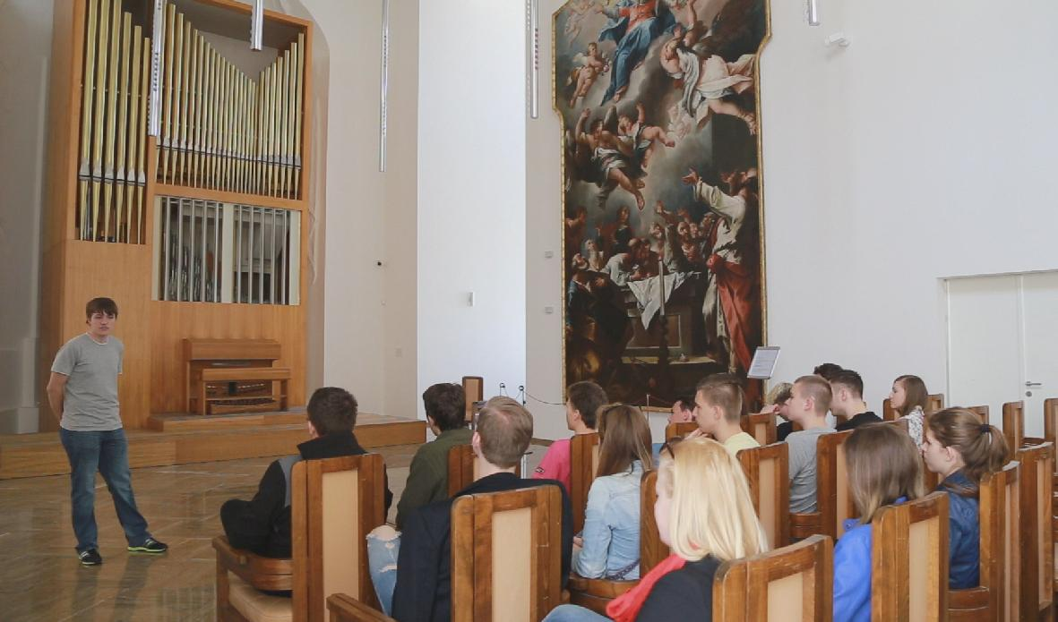
The Music Hall used to be a castle chapel. The large painting which dominates this hall is the work of Anton Schmidt, who originally came from Vienna but lived in and worked in Banská Štiavnica. This baroque oil paiting used to be a part of the altar decoration in the church of the town of Kremnica. After being demolished due to its very bad condition, the painting was carefully restored and transfered to the castle. Due to perfect accoustics in that hall, The Days of Organ Music as a part of Cultural Summer Festival are held here annually.
The beautiful ceiling is decorated with paintings, all works of Venetian artists from the 16th century. This room built in Renaissance style is one of the most beautiful parts of the castle and luckily it survived the fire of 1811.

THE SECOND FLOOR
The Picture Gallery
The beautiful halls of the picture gallery contain paintings most of which come from the National Historical Museum collection as well as from other Slovak National museums.
In the period of Maria Theresa the palace contained precious art collections, a library and a picture gallery. Later all the pieces of art were moved to Vienna and formed the core of the now famous Vienna Albertina Art Collection.
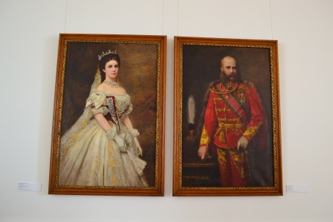
The tapestry on the walls is probably the most valuable piece of work in the castle. It shows the story of Ester, which dates back to year 1560. It might have been made in a workshop of the town of Luneburg in Germany.
A painting worth seeing is the Hunting scene. The painting is from the first half of the 16th century.

You can have a look at the portraits of the members of the royal and emperor Habsburgh family.
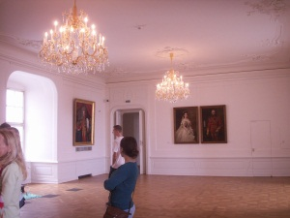
Portraits of the most influential representatives of Hungarian aristocracy are on display in the other halls of the gallery.

The crown tower
The crown tower is the only architectural element which remained from the original Romanesque castle. This tower, in the comparison to the three other towers, does not stand on the castle wall, but it has its own grounding. Originally it was erected after the Tatar invasion in the 13th century in the corner of the fortification and served as a watchtower. The tower which is 47 meters high survived later reconstructions and became an internal part of the castle.

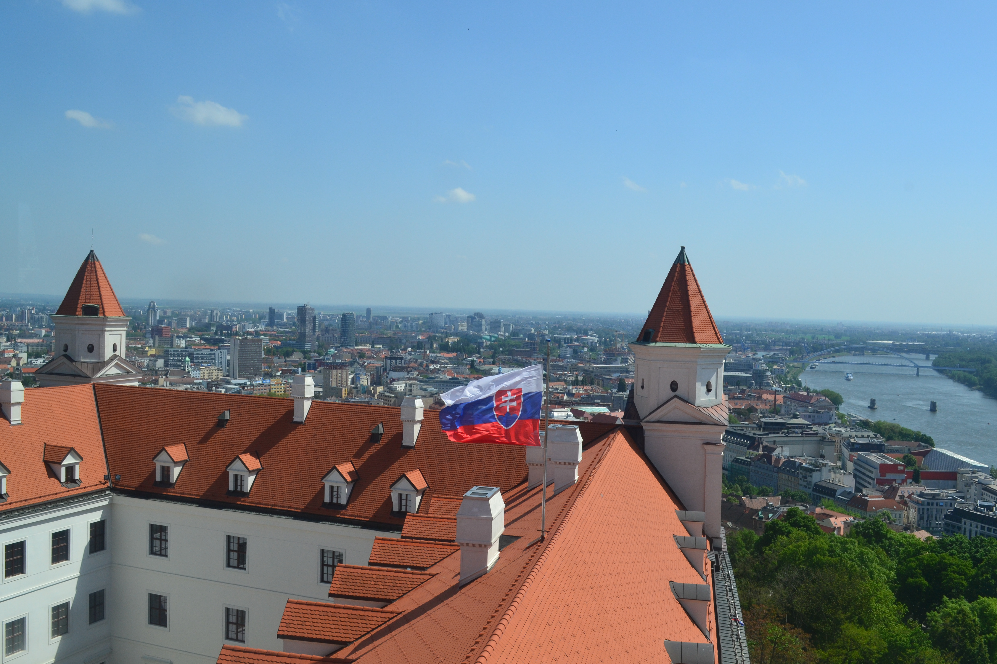
This tower is accessible also from the second floor (the art gallery). It is worth walking up the stairs if you want to enjoy a panoramic view of Bratislava.

In the near future a replica of Hungarian Crown jewels will be on display. The original precious jewels were moved from here after Bratislava lost its position of being a coronation town. Today King Stephan´s crown is on display in Budapest Parliament.

THE THIRD FLOOR
This floor presents temporary exhibitions, so check on the Internet what kind of exhibition is presented currently.
The Treasure room and the Knights´ Hall are accessible from the inner court. Watch the signs saying where to enter them.

The Treasure room
The room contains the exhibition of the newest archaeological findings from the castle hill. In the display cases there are findings from the Prehistoric Age – Eneolit. Here are vessels and tools used to prepare and store food, tools to process leather or wood or tools used on other occasions.
Other cases present some findings from the time of the next important inhabitants of the castle hill – the Romans and Celts. The northern border of the Roman Empire was on the Danube. At that time – that is, in the late Iron Age – there was a Celtic Oppidum on the castle. The findings are the newest proofs of the importance and the extent of the cooperation between the Celts and Romans in this space.

There is also an important collection of Celtic coins. There are fifteen of them, with an inscription BIATEC or NONNOS on them, who were supposed lords of the Celts in this Oppidum. These coins were found in the floor of the so called “Roman house” – a house of the Roman type – behind the present castle.
Also other displayed items originate from the Celtic Oppidum and provide further proofs of the high level of development in this area and the level of cooperation between the Celts and Romans.
A bronze seal case proves the literacy of the inhabited Celts, (although it was known from the coins that they knew letters) the presence of the seal means a real ability to communicate in written form.
There is a fully preserved Celtic bell on display and also an amber fragment and other findings.
The Teasure room offers a sight of parts of the wall, coating and also of the pavement from a Roman house. The rhombic particles mixed into the material are Roman ceramic fragments. The researchers suggest that such a Roman construction technique indicates that the Celts invited Roman builders to the Oppidum.
This is the only part of the castle were taking photographs is forbidden.

Knights´ Hall
The Knights´Hall was built at the same time as the Treasury during the reconstruction under Sigismund of Luxemburg. During the reconstruction in the second half of the 20th century, there was an attempt to change it back into its gothic form, although it wasn’t possible entirely – for example, the original floor of the room is about two meters beneath the present floor.
It was right here in this room were the Constitutional law of the Czechoslovak Federation was signed in October 1968. It is not the only constitutional law signed in this room, the current Constitution of the Slovak Republic was also signed here in 1992.
SOME INTERESTING FACTS ABOUT THE CASTLE
- The castle is 85 m above the river Danube level, there is an 85-metre deep well in its courtyard, the tower of St. Martin’s Cathedral is 85 m high, and the café which tops the Slovak National Uprising bridge is 85 m above the ground.
- The first record about Bratislava castle dates back to 907.
- The first paintings depicting Bratislava castle are from the 14th century.
- In the 2004 nationwide survey the stamp with the motif of Bratislava castle from the 14th. c. was chosen as the most outstanding stamp.
- 10, 20, 50 cent euro coins present Bratislava castle as the most visited Slovak landmark.
- Wolfgang Kempelen constructed devices that transported water from the Danube river up to the castle.
- Bratislava castle was one of the best fortified castles in the Hungarian Kingdom.
- There used to be a pharmacy in the castle in the 18th c..
- In the baroque stables during the reign of Maria Theresa several precious horses were kept.
- During the medieval period two important trade routes known as the Danube road (led along the Danube from the west to east) and the Amber road (linking southern countries of Europe with Baltic states) met under the castle.
- The closest castles on the Danube are: Devín Castle (Slovakia), Pottenburg Castle (Austria) and Hainburg Castle (Austria).
- Elizabeth of Hungary was born in Bratislava Castle in 1207. She was known for helping the poor.
- Besides Hungarian monarchs, Holy Roman and Austrian emperors, the castle was also visited by Peter I the Great (1698), French emperor Napoleon Bonaparte (1805) and Hans Christian Andersen, a famous Danish story-tale author (1841).
- On February 24, 2005 the summit meeting of the US President George W. Bush and Russian President Vladimír Putin took place at the castle.
- The Slovak Republic will hold the Presidency of the Council of European Union in 2016 in Bratislava castle.
- As for the architecture, the castle presents examples of gothic, rennaisance and baroque styles.
INFORMATION ABOUT THE CASTLE
Address:
SNM - Historické múzeum; Bratislavský hrad
Zámocká 2 - Hradný palác
811 01 Bratislava 1
GPS: {N 48.142276, E 17.100043}
E-mail: bratislavskyhrad@snm.sk
Telephon: +421 2 204 83 104, 0915 99 33 01
Opening hours:
1 April – 16 November
Tuesday – Sunday: 10.00 - 18.00
17 November – 31 March
Tuesday – Sunday: 9.00 - 17.00
Price list:
Round A (all parts of the castle)
- the lenght: 45-90 min.
Admission: 6 €
Seniors , students 3 €
Family entrance tickets:
1 adult + 2 children 8 €
2 adults + max. 3 children 15 €
Group of students: 1 €
Taking photos: 2 €

Round B (the Treasury only)
- the lenght: up to 30 min.
Adults: 2 €
Seniors, students: 1 €

Guided tour sholud be booked in advance
Guided tour in Slovak language: 10 € /group
Guided tour in English/German: 15 € /group

Booking: bratislavskyhrad@snm.sk
tel.: +421 220 483 110, +421 915 993 301

See more at: http://www.visit.bratislava.sk/

